**EXPERIMENT NO.2**

**BY- Gatik Veer**

**Roll N.o. - 2110990493**

**AIM:** Setting up a GitHub Account.

First step in starting with GitHub are to create an account, choose a product that fits your needs best, verify your email, set up two-factor authentication, and view your profile.

There are several types of accounts on GitHub. Every person who uses GitHub has their own user account, which can be part of multiple organisations and teams. Your user account is your identity on GitHub.com and represents you as an individual.

**Creating an Account :**

* Open your web browser and search <http://github.com> This will open the following page:



* Now click on ‘Sign Up’ on the upper-right conner of desktop window. This will open a new page where we must enter our email address for our account.****

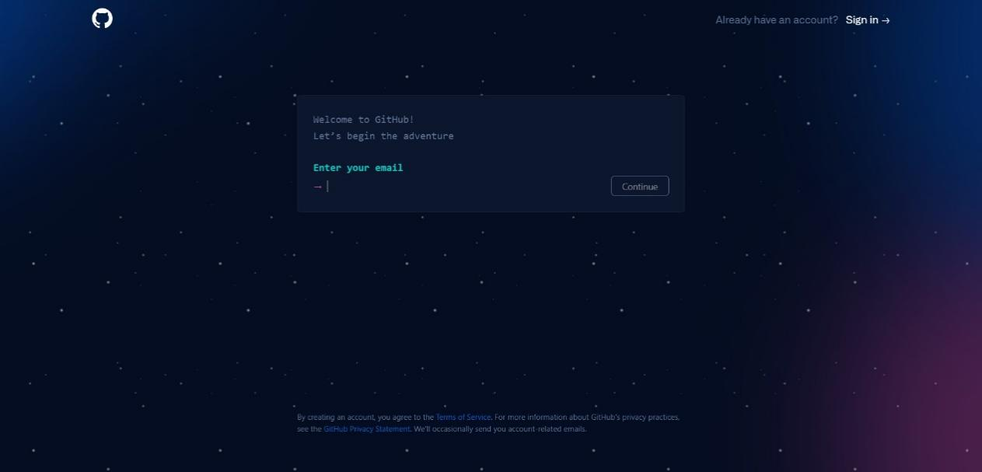

* Now type in the password and username you want to use for your GitHub account and click on ‘Create Account’.
* Now verify the email and our Github account is ready.

